**UTICA COLLEGE**

**GRADUATE STUDIES**

**MASTER’S IN DATA SCIENCE**

MSDS THESIS

**Pan-Collagen Gene Copy Number Variation Survival Analysis of Ovarian Neoplasms from the TCGA Database**

by

Dr. Robert I. Hodges

PharmD, Medical University of South Carolina, 2010

MBA, The Citadel Graduate College, 2012

Submitted for fulfillment of requirements for degree of

Master of Science in Data Science

July 2021

**Personal Acknowledgements**

I would like to thank Dr. John Christian Givhan Spainhour for mentorship, dedicated time to teaching over many phone calls, and helping guide me to this thesis subject. Christian has been a great friend over the years and has helped guide me in the world of data and statistics as I change careers. His teachings have pushed me to think more critically about my own thought processes and help hone my data science skills. His knowledge and expertise have been invaluable, and I am truly thankful and lucky to call him a mentor and a great friend.

I would also like to thank Dr. Brandee Rockefeller for time given in mentoring me and providing guidance on this thesis. Her guidance has made this research much more fluid, better outlined, and more professional.

I would also like to thank Dr. Michael McCarthy for helping guide me from the beginning of this journey in the master’s in data science program and offering the thesis research project as an option. I also thank him for his time and commitment in helping sharpen this research and thesis and other data science skills.

I would also like to thank a personal data scientist friend, Hansen Grider, for also guiding me on various data science issues and topics I have run across which has kept me on course. His friendship and knowledge have been truly significant.

I would also like to thank my primary data scientist mentor, Fred Frost, who has helped guide me in learning what I need to learn to be successful in the data science world. His mentorship has been invaluable and helps keep me on the best path.

I also thank my fantastic wife, Vasilina Hodges, for putting up with me these past couple of years while working on this research and the master’s in data science program. Her tolerance and understanding have been a key part of my growth in data science and her support has been overwhelming. I love you and thank you.

**Table of Contents** Page Number

Abstract ……………………………………………………………………………………. 5

Introduction………………………………………………………………………………… 6

Literature Review…………………………………………………………………………... 8

Methods……………………………………………………………………………………... 9

Results………………………………………………………………………………………. 11

Discussion…………………………………………………………………………………... 14

References…………………………………………………………………………………... 17

Appendix A…………………………………………………………………………………. 21

Appendix B…………………………………………………………………………………. 21

Appendix C…………………………………………………………………………………. 22

Appendix D…………………………………………………………………………………. 26

Abbreviations……………………………………………………………………………….. 28

**Abstract**

The Cancer Genome Atlas (TCGA) is a large longitudinal database of cancer patients with varying cancer types which has led to many studies being published (*The Cancer Genome Atlas Program*, 2019). This study, also from TCGA, performed survival analysis, log-rank scoring, and Cox proportional hazard models comparing collagen gene copy number variation in ovarian cancer patients from the TCGA repository. Data cleaning was performed initially in Alteryx Designer and secondary data cleansing and analysis was performed in RStudio. Stratification was performed on copy number variation showing stratification alignments of deletion, normal, and duplication. Results found that 3 genes: COL12A1, COL4A3BP, and COL5A3 to have statistically significance relationships between decreased survival and copy number variation abnormalities. This study supports current literature and provides further evidence that collagen gene copy number variations can have multiple effects on tumorigenesis in ovarian neoplasm patient survival.

**Introduction**

The Cancer Genome Atlas (TCGA) has analyzed over 20,000 cancer observations across 33 different cancer types (Liu et al., 2018). TCGA has been a colossal repository of genetic information pertaining to various neoplasm types with numerous publications emanating from this database alone, including novel discoveries concerning ovarian cancer (TCGA - Ovarian Serous Adenocarcinoma Study, 2018).

Ovarian cancer has a relative survival risk of 80% and is considered the most lethal gynecological cancer type (Cancer.org, 2014). One factor to be considered in ovarian cancer outcomes is the role of collagen (Xu et al., 2019). Collagen has been studied to some extent as various mechanisms have been discovered with regards to function in ovarian tumors; however, further research is needed (Ricciardelli & Rodgers, 2006).

Collagen is an extracellular matrix (ECM) that forms a barrier around organs and blood vessels (Dipiro et al., 2017, p. 917). Collagen is the most abundant type of ECM located in the ovaries (Cho et al., 2015). There are multiple factors which contribute to the growth of tumors including ECM remodeling, various growth factors, and other tissue inhibitors. Collagen is an essential component in homeostasis and ECM remodeling, such as ECM stiffness and elasticity, are implicated in ovarian tumorigenesis progression (Cho et al., 2015).

ECM is also essential in the regulation of ovarian cell morphology through various mechanisms such as cell communication and cell shape (Woodruff & Shea, 2007). For example, in tumorigenesis, collagen is remodeled into thick fibrils (Cho et al., 2015). This structure of fibrils is regulated by the COL12A1 gene, which is the collagen type XII alpha 1 chain in homo sapiens (NCBI – COL12A1, 2020). However, research also focuses on drug resistance as sometimes drug resistance can be due to functional abnormalities rather than structural like ECM (Holohan et al., 2013). For example, the COL4A3BP gene, also known as the ceramide transfer protein (CERT) gene and more commonly known as the gene determinant in Goodpasture disease, produces a protein which is a regulator of ceramide transport and has been implicated in multidrug resistance in certain cancer treatments such as colorectal and breast cancer (Lee et al., 2011).

Understanding ECM organization and cell morphology is essential in understanding and gaining insights of malignant neoplasms and their processes (Cho et al., 2015). Copy number variation (CNV) has been linked to complicated traits and behaviors in diseases and drug resistance (Gamazon & Stranger, 2015). This study evaluates the collagen genetic component behind ECM organization and cell morphology in ovarian cancer by exploring heterogenous pan-collagen gene CNV and patient survival relationships in ovarian cancer.

In this study, Kaplan-Meier survival analysis (KM), log-rank tests, and Cox-proportional hazard modeling was performed on ovarian cancer patient CNV mutations in 55 different collagen genes in ovarian cancer from the TCGA database. The null hypothesis states no statistical differences in survival in ovarian cancer patients with any of the 55 collagen genes based on CNV stratification will be identified. The alternative hypothesis indicates there is a statistical difference in survival in ovarian cancer patients regarding CNV. For survival analysis the dependent variable is the time to event, death, or loss of contact while independent variables are gene CNVs.

Survival analysis is essential in CNV exploration as we can potentially refine medical treatment for a more individualized approach in personalized medicine and target therapy and this importance has been emphasized in genetic literature (Gamazon & Stranger, 2015).

Hopefully by increasing the genetic knowledge base, a significant impact on patient outcomes may be achieved. This research has potential to assist the need for targeted collagen or targeted gene therapies in ovarian neoplasm treatment.

**Literature Review**

TCGA has produced multiple studies that contribute to human understanding of genetics (The Cancer Genome Atlas – Publications, 2019). Ovarian cancer has been studied with regards to collagen in the past, however, very little has been researched regarding CNV. A PubMed literature search was performed using medical subject heading (MeSH) terms for “Ovarian Neoplasms” and “Collagen”. Literature review was performed for 293 results involving genetic studies involving collagen and ovarian neoplasms.

Gene expression is generally the most common researched topic with regards to neoplasms as normalization techniques in high-throughput RNA sequencing are more available and widely used (Dillies et al., 2012). For example, gene-drug interactions in ovarian cancer has been researched previously but with respects to gene expression instead of CNV (Teng et al., 2013). High-throughput RNA sequencing advances may be the reason why CNV has not been studied as often as gene expression.

Collagen has been shown to be involved in multiple aspects of tumorigenesis as previously mentioned (Cho et al., 2015). One study has previously linked collagen gene expression to metastasis promotion through the transforming growth factor (TGF-β1) signaling pathway (Cheon et al., 2013). Another linked the collagen gene COL2A1 and higher gene expression with delayed tumor relapse in high-grade ovarian cancer patients (Ganapathi et al., 2015). Drug resistance due to collagen gene expression by inhibiting molecular penetration and in turn decreasing tumor apoptosis has been studied as well in ovarian neoplasms and hypothesized with gene expression of COL5A3 (Januchowski et al., 2016). Another study found decreased gene expression levels of XI alpha 1 collagen gene COL11A1 with decreased ovarian tumor invasiveness and oncogenic potential (Wu et al., 2013).

However, some investigation has been done regarding CNV and TCGA. One study investigated gene-drug interactions with regards to CNV in glioblastoma multiforme and lower grade brain glioma (Spainhour & Qiu, 2016).

As an important bias to mention from TCGA literature, sequence homology can create technical artifacts, which in turn affects downstream analysis and mapping which potentially also cause concerns (Webster et al., 2019). These sequence homologies are created from shared evolutionary roots where DNA regions share high similitude. This phenomenon has also been found in TCGA data (Buckley et al., 2017). This can possibly create bias in the genetic database where about 5-10% of cancer patients may be more predisposed to certain cancer types (Garber & Offit, 2005). This is important as cancer is caused by inherited germline variations and somatically acquired changes and these two types of neoplasm progenitors may work synergistically (Buckley et al., 2017).

**Methods**

Patient clinical and survival data was pulled from TCGA database under the TCGA-OV project (ovarian cancer). CNV data was pulled from The Broad Institute of MIT and Harvard, which is part of TCGA, from the ovarian cancer archives in the form of comma separated value (CSV) files (*Broad GDAC Firehose*, 2016). The original files were not modified for data integrity purposes. Data was initially cleaned and joined using Alteryx Designer (Version 2019.4.8.22007) and data cleaning workflow can be referenced in Appendix A. Additional data cleaning and exploratory data analysis (EDA) was performed on the new data frame with the DataExplorer package in RStudio (Version 1.2.5033) and analysis was completed with SurvMiner and Survival packages in RStudio. Charts were made in Microsoft Excel.

55 collagen gene CNV columns were analyzed in EDA. Varying distributions of each gene were found and can be seen in Appendix B. CNV range for each gene spanned from negative two through positive two. Table 1 lists the reference to each value and stratified groupings into smaller groups for ease of analysis.

**Table 1. Copy Number Variation (CNV) Description and Stratified Groupings**

|  |  |  |
| --- | --- | --- |
| Value | Description | Stratified Groupings |
| -2 | Complete Deletion | Deletion |
| -1 | Partial Deletion |
| 0 | Normal | Normal |
| 1 | Partial Duplication | Duplication |
| 2 | Complete Duplication |

The timeframe column titled “Days.to.Death” displayed a skewed right distribution with a high spike at the beginning of the timeframe. Maximum days to death was 5,481 days and minimum was eight days with a median of 864 days and a mean of 989 days. There were 564 observations with the status column displaying 291 events of death and 273 censored non-events. Censoring is defined as where the event, death, did not occur during the observation (Prinja et al., 2010). Censoring is either due to loss of follow-up data or non-occurrence of event in this study.

Kaplan-Meier survival curves (KM) were applied to all independent variables. Genes COL12A1, COL4A3BP, COL5A3 were found statistically significant with a p-value threshold of < 0.05. Log-rank tests and Cox-proportional hazard models were applied to the three significant findings.

**Results**

Primary results are displayed in Table 2.

**Table 2. Primary Results**

|  |  |  |  |  |
| --- | --- | --- | --- | --- |
| Gene | CNV Stratification | P-value | Coefficient | Exp(Coef) – Hazard Ratio (95% CI) |
| COL12A1 | DELETION | 0.046* |  |  |
|  | DUPLICATION | 0.0245* | -0.36 | 0.6977 (0.5098 - 0.9547) |
|  | NORMAL | 0.0629 | -0.2451 | 0.7826 (0.6044 - 1.0133) |
| COL4A3BP | DELETION | 0.021* |  |  |
|  | DUPLICATION | 0.00696** | 0.80615 | 2.239 (1.2470 – 4.021) |
|  | NORMAL | 0.58518 | 0.07492 | 1.078 (0.8236 – 1.410) |
| COL5A3 | DELETION | 0.014* |  |  |
|  | DUPLICATION | 0.00548** | -0.3818 | 0.6827 (0.5214 – 0.8937) |
|  | NORMAL | 0.04536* | -0.2992 | 0.7414 (0.5531 – 0.9938) |

**\*Denotes statistical significance with p-value < 0.05.  
**Denotes statistical significance with p-value < 0.01.**

All three gene survival models were statistically significant, however, not all CNV stratifications were significant. Only gene COL5A3 was within significance between deleted, normal, and duplicated CNV stratification.

In the Cox-proportional hazard model, the COL5A3 coefficients were negative for normal and duplication CNV when compared to deletion CNV. This means that normal and duplicated CNV levels in this gene have increased survival probability as it is negatively correlated to the event. Coefficients for COL12A1 were also negative showing the same survival probability increase. COL4A3BP had positive coefficients which imply lower probability of survival with duplicated and normal CNV, however, only duplication and deletion CNV was statistically significant.

Hazard ratios for statistically significant findings include COL12A1 duplication at 0.6977 which approximately translates to a 0.7:1 ratio for chance of death. This is approximately a 30% decreased probability of death in this stratification. In gene COL4A3BP for duplicated CNV is a hazard ratio of 2.239 which translates to a 2.24:1 ratio for increased chance of death which is a 224% probability increase in death for this gene stratification. Hazard ratios for COL5A3 were both statistically significant for duplication and normal CNV at 0.6827 and 0.7414, respectively. These translate to a ratio of 0.68:1 ratio and 0.74:1 ratio for chances of death; or a 32% and 26% decreased chance of death, respectively, for duplication and normal CNV.

Shown in Appendix C are KM curves for all 3 genes. Gene COL5A3 has a very distinct and visible survival difference between 1100 days and 1700 days, but then converges again to where all 3 stratifications do not show much differentiation around day 2000, but then splits off again. Duplication of CNV seems to show greater probability of survival through most of the KM curve for COL5A3.

Gene COL12A1 illustrates deletion of CNV with a lower survival probability starting around 1000 days, however, normal CNV was not statistically significant in this model. When comparing deletion against duplication CNV in the KM curves, there is a clear distinction between the two since normal is not statistically significant.

COL4A3BP is only significant with regards to duplication when compared to deletion CNV. Normal CNV was not statistically significant and can be seen in the KM curves to closely mimic the deletion CNV curve.

Table 3 displays log-rank scores of each gene with asterisks marking statistical significance.

**Table 3. Log-rank Scores of Each Stratified Gene.**

|  |  |  |  |
| --- | --- | --- | --- |
| Gene | N | Observed | Expected |
| COL12A1 = Deletion* | 196 | 118 | 98.8 |
| COL12A1 = Duplication* | 134 | 60 | 71.6 |
| COL12A1 = Normal | 234 | 113 | 120.7 |
| COL4A3BP = Deletion* | 410 | 207 | 215.64 |
| COL4A3BP = Duplication* | 21 | 12 | 5.63 |
| COL4A3BP = Normal | 133 | 72 | 69.73 |
| COL5A3 = Deletion* | 193 | 110 | 87.5 |
| COL5A3 = Duplication* | 217 | 105 | 121.9 |
| COL5A3 = Normal* | 154 | 76 | 81.5 |

**\*Denotes statistical significance with p-value < 0.05**. **-Highlighted in red are observed events which are greater than expected events, showing a decreased probability of survival in the models.**

Log-rank scores show the numerical differences in events that are expected vs observed.

Hazard models plotted over time are displayed in Appendix D. The beta line is not within the 95% confidence interval one hundred percent of the time for any of the three models. However, these models still have good fit to the data.

Table 4 lists median days of survival with upper and lower limits of confidence intervals with asterisk marking statistical significance.

**Table 4. Median Days of Survival with Confidence Interval Limits**

|  |  |  |  |  |  |
| --- | --- | --- | --- | --- | --- |
| Name | N | Events | Median | 0.95LCL | 0.95UCL |
| COL12A1=Deletion* | 196 | 118 | 1259 | 1091 | 1380 |
| COL12A1=Duplication* | 134 | 60 | 1451 | 1204 | 2148 |
| COL12A1=Normal | 234 | 113 | 1249 | 1249 | 1686 |
| COL4A3BP=Deletion* | 410 | 207 | 1336 | 1204 | 1492 |
| COL4A3BP=Duplication* | 21 | 12 | 457 | 256 | NA |
| COL4A3BP=Normal | 133 | 72 | 1384 | 1213 | 1686 |
| COL5A3=Deletion* | 193 | 110 | 1102 | 1046 | 1264 |
| COL5A3=Duplication* | 217 | 105 | 1446 | 1278 | 1595 |
| COL5A3=Normal* | 154 | 76 | 1516 | 1364 | 1757 |

**\*Denotes statistical significance with p-value < 0.05.**

COL12A1 does have overlap in the limits of confidence intervals. However, comparison of normal to duplication CNV in this gene there is no overlap of the confidence interval.

COL4A3BP shows a NA value meaning the confidence interval could not be calculated for this as the data for this stratification is sparse. More data is needed for this and should be investigated more.

COL5A3 shows clear non-overlap in the limits of confidence intervals when comparing deletion to normal CNV and deletion to duplication CNV.

**Discussion**

These are novel results and have not been previously published. However, these findings should be further investigated based on the possibility of false discovery previously mentioned in other literature as this is a risk with genetic research (Efron, 2005). The reasoning for this is having an alpha level set at 0.05. There are an estimated 30,000 genes in the human body (Human Genome Project FAQ, 2013). There are 1,500 genes that could potentially have a finding that is random with an alpha set at 0.05 (Genetics Home Reference, 2019). However, very few genetic studies seem to use any controls for false discovery and are generally due to lack of quality and quantity of data (Dahiru, 2011). This bias should be kept in mind as the primary limitation to this study is quality and quantity of data. Obtaining genetic data is quite difficult and expensive as the cost of TCGA as of 2015 is $375 million (“The Future of Cancer Genomics”, 2015). Although gene sequencing is becoming cheaper and more accurate, a strong argument can be made for keeping alpha at 0.05 with confidence intervals and not controlling for false discovery (Ulrich, 2016). While objectivity is a strong goal to maintain in any study and can be difficult to achieve, finding appropriate data in genetics is just as difficult.

Another argument for not controlling for false discovery are the underlying mechanisms showing collagen has multiple and various effects on ovarian neoplasms (Xu et al., 2019). Selecting a subset of specific genes with known effects on a specific neoplastic tissue seems appropriate. One would not randomly pick a set of genes to investigate where the gene is not expressed in the tissue being studied. Thus, this strengthens the argument for using alpha set at 0.05 and not using a Bonferroni p-value correction.

The methods for CNV detection with high-throughput sequencing also contribute to false discovery rates (Jiang et al., 2018). An increase in observations would be appropriate to help control for this. It is also possible that a combination of TCGA repository and future cancer databases could be utilized and combined to increase observation numbers, such as the Genotype Tissue Expression Project (GTEx) which has been combined with the TCGA (Wang et al., 2018). It is possible that this future research structure may not be feasible with technology advancing in genomics at a fast rate as sequencing methods do evolve. However, TCGA is such an enormous longitudinal archive of genetic information, more CNV survival analysis studies should be performed on other cancers to help create a baseline knowledge of CNV and collagen effects on neoplasms.

Another bias worth mentioning is that data collection was done by multiple people at different locations, as this is secondary data. It is difficult to analyze the integrity of the data in TCGA. However, care has been taken in the data collection process for use in quantitative polymerase chain reaction (qPCR) and uses a genetic reference to allow qPCR normalization which has allowed greater consistency when performing research from the TCGA database (Krasnov et al., 2019). As previously stated, there has even been recent work where the GTEx was combined with the TCGA into a pipeline which unifies RNA sequencing data and therefore allows greater normalization (Wang et al., 2018).

Because there are evolutionary artifacts in the TCGA germline based on natural selection, future CNV research should possibly be performed on a new cancer repository (Webster et al., 2019). It is most likely that the evolutionary artifacts have not introduced much bias into this study. However, one should be aware that they exist and that they are not able to be controlled for in this research, as quantity and quality of data is are limiting factors. Evolutionary artifacts would most likely not make a difference in treatment options that may arise from research such as this.

Studies such as this can be considered foundational to personalized cancer treatments and target therapy. However, most antineoplastic molecules are of a narrow therapeutic index and small dose alterations may lead to toxicity (Eaton & Lyman, 2019). A two to three gene CNV signature test could possibly be implemented from studies such as this to present information about probability for survival to the patient and physician. This potential CNV signature could also be assimilated into a gene expression and CNV panel for a more complete study in predictive power of genetics and proteomics in patient survival.

**References**

*Broad GDAC Firehose*. (2016). Broadinstitute.Org. http://gdac.broadinstitute.org/

Buckley, A. R., Standish, K. A., Bhutani, K., Ideker, T., Lasken, R. S., Carter, H., Harismendy, O., & Schork, N. J. (2017). Pan-cancer analysis reveals technical artifacts in TCGA germline variant calls. *BMC Genomics*, *18*(1). <https://doi.org/10.1186/s12864-017-3770-y>

Cancer.org, 2014; Survival Rates of Ovarian cancer. *American Cancer Society.* <https://www.cancer.org/cancer/ovarian-cancer/detection-diagnosis-staging/survival-rates.html>

Cheon, D.-J., Tong, Y., Sim, M.-S., Dering, J., Berel, D., Cui, X., Lester, J., Beach, J. A., Tighiouart, M., Walts, A. E., Karlan, B. Y., & Orsulic, S. (2013). A Collagen-Remodeling Gene Signature Regulated by TGF-β Signaling Is Associated with Metastasis and Poor Survival in Serous Ovarian Cancer. *Clinical Cancer Research*, *20*(3), 711–723. <https://doi.org/10.1158/1078-0432.ccr-13-1256>

Cho, A., Howell, V. M., & Colvin, E. K. (2015). The Extracellular Matrix in Epithelial Ovarian Cancer – A Piece of a Puzzle. Frontiers in Oncology, 5. https://doi.org/10.3389/fonc.2015.00245

Dahiru, T. (2011). P-Value, a true test of statistical significance? a cautionary note. *Annals of Ibadan Postgraduate Medicine*, *6*(1). <https://doi.org/10.4314/aipm.v6i1.64038>  
‌

Dillies, M.-A., Rau, A., Aubert, J., Hennequet-Antier, C., Jeanmougin, M., Servant, N., Keime, C., Marot, G., Castel, D., Estelle, J., Guernec, G., Jagla, B., Jouneau, L., Laloe, D., Le Gall, C., Schaeffer, B., Le Crom, S., Guedj, M., & Jaffrezic, F. (2012). A comprehensive evaluation of normalization methods for Illumina high-throughput RNA sequencing data analysis. *Briefings in Bioinformatics*, *14*(6), 671–683. <https://doi.org/10.1093/bib/bbs046>

Dipiro, J. T., Talbert, R., Yee, G., Matzke, G., Wells, B., & Posey, L. M. (2017). Pharmacotherapy-- a pathophysiologic approach (10th ed., p. 917). Mcgraw-Hill Education.

Eaton, K., & Lyman, G. (2019). Dosing of anticancer agents in adults. *UpToDate*. https://www.uptodate.com/contents/dosing-of-anticancer-agents-in-adults

‌Efron, B. (2005). Bayesians, Frequentists, and Scientists. *Journal of the American Statistical Association*, *100*(469), 1–5. <https://doi.org/10.1198/016214505000000033>

Gamazon, E. R., & Stranger, B. E. (2015). The impact of human copy number variation on gene expression: Figure 1. *Briefings in Functional Genomics*, *14*(5), 352–357. https://doi.org/10.1093/bfgp/elv017‌

Ganapathi, M. K., Jones, W. D., Sehouli, J., Michener, C. M., Braicu, I. E., Norris, E. J., Biscotti, C. V., Vaziri, S. A. J., & Ganapathi, R. N. (2015). Expression profile of COL2A1 and the pseudogene SLC6A10P predicts tumor recurrence in high-grade serous ovarian cancer. *International Journal of Cancer*, *138*(3), 679–688. <https://doi.org/10.1002/ijc.29815>

Garber, J. E., & Offit, K. (2005). Hereditary Cancer Predisposition Syndromes. *Journal of Clinical Oncology*, *23*(2), 276–292. <https://doi.org/10.1200/jco.2005.10.042>  
‌

Genetics Home Reference. (2019). *What is a gene?* Genetics Home Reference. <https://ghr.nlm.nih.gov/primer/basics/gene>

Holohan, C., Van Schaeybroeck, S., Longley, D. B., & Johnston, P. G. (2013). Cancer drug resistance: an evolving paradigm. *Nature Reviews Cancer*, *13*(10), 714–726. https://doi.org/10.1038/nrc3599

‌*Human Genome Project FAQ*. (2013). Genome.Gov. <https://www.genome.gov/human-genome> project/Completion-FAQ

‌Januchowski, R., Świerczewska, M., Sterzyńska, K., Wojtowicz, K., Nowicki, M., & Zabel, M. (2016). Increased Expression of Several Collagen Genes is Associated with Drug Resistance in Ovarian Cancer Cell Lines. *Journal of Cancer*, *7*(10), 1295–1310. <https://doi.org/10.7150/jca.15371>

Jiang, Y., Wang, R., Urrutia, E., Anastopoulos, I. N., Nathanson, K. L., & Zhang, N. R. (2018). CODEX2: full-spectrum copy number variation detection by high-throughput DNA sequencing. *Genome Biology*, *19*(1). <https://doi.org/10.1186/s13059-018-1578-y>

Krasnov, G. S., Kudryavtseva, A. V., Snezhkina, A. V., Lakunina, V. A., Beniaminov, A. D., Melnikova, N. V., & Dmitriev, A. A. (2019). Pan-Cancer Analysis of TCGA Data Revealed Promising Reference Genes for qPCR Normalization. *Frontiers in Genetics*, *10*. https://doi.org/10.3389/fgene.2019.00097

Lee, A. J. X., Roylance, R., Sander, J., Gorman, P., Endesfelder, D., Kschischo, M., Jones, N. P., East, P., Nicke, B., Spassieva, S., Obeid, L. M., Birkbak, N. J., Szallasi, Z., McKnight, N. C., Rowan, A. J., Speirs, V., Hanby, A. M., Downward, J., Tooze, S. A., & Swanton, C. (2011). CERT depletion predicts chemotherapy benefit and mediates cytotoxic and polyploid-specific cancer cell death through autophagy induction. *The Journal of Pathology*, *226*(3), 482–494. <https://doi.org/10.1002/path.2998>  
‌

Liu, J., Lichtenberg, T., Hoadley, K. A., Poisson, L. M., Lazar, A. J., Cherniack, A. D., Kovatich, A. J., Benz, C. C., Levine, D. A., Lee, A. V., Omberg, L., Wolf, D. M., Shriver, C. D., Thorsson, V., Hu, H., Caesar-Johnson, S. J., Demchok, J. A., Felau, I., Kasapi, M., … Mariamidze, A. (2018). An Integrated TCGA Pan-Cancer Clinical Data Resource to Drive High-Quality Survival Outcome Analytics. *Cell*, *173*(2), 400-416.e11. <https://doi.org/10.1016/j.cell.2018.02.052>

*NCBI - COL12A1*. (2020, October 25). Www.Ncbi.Nlm.Nih.Gov; NCBI. https://www.ncbi.nlm.nih.gov/gene/1303

‌Prinja, S., Gupta, N., & Verma, R. (2010). Censoring in Clinical Trials: Review of Survival Analysis Techniques. *Indian Journal of Community Medicine : Official Publication of Indian Association of Preventive & Social Medicine*, *35*(2), 217–221. https://doi.org/10.4103/0970-0218.66859

‌Ricciardelli, C., & Rodgers, R. (2006). Extracellular Matrix of Ovarian Tumors. *Seminars in Reproductive Medicine*, *24*(4), 270–282. <https://doi.org/10.1055/s-2006-948556>

Rocher, L., Hendrickx, J. M., & de Montjoye, Y.-A. (2019). Estimating the success of re identifications in incomplete datasets using generative models. *Nature Communications*, *10*(1). https://doi.org/10.1038/s41467-019-10933-3

‌Spainhour, J. C. G., & Qiu, P. (2016). Identification of gene-drug interactions that impact patient survival in TCGA. *BMC Bioinformatics*, *17*(1). [https://doi.org/10.1186/s12859-016 1255-7](https://doi.org/10.1186/s12859-016%091255-7)

TCGA - Ovarian Serous Adenocarcinoma Study. (2018, September 5). [Www.Cancer.Gov](http://Www.Cancer.Gov). <https://www.cancer.gov/about-nci/organization/ccg/research/structural> genomics/tcga/studied-cancers/ovarian  
‌

Teng, P.-N., Wang, G., Hood, B. L., Conrads, K. A., Hamilton, C. A., Maxwell, G. L., Darcy, K. M., & Conrads, T. P. (2013). Identification of candidate circulating cisplatin-resistant biomarkers from epithelial ovarian carcinoma cell secretomes. *British Journal of Cancer*, *110*(1), 123–132. <https://doi.org/10.1038/bjc.2013.687>

*The Cancer Genome Atlas Program*. (2019). National Cancer Institute; Cancer.gov. <https://www.cancer.gov/about-nci/organization/ccg/research/structural-genomics/tcga>

*The Cancer Genome Atlas - Publications*. (2019). National Cancer Institute; Cancer.gov. <https://www.cancer.gov/about-nci/organization/ccg/research/structural-genomics/tcga/publications>  
‌

The future of cancer genomics. (2015). *Nature Medicine*, *21*(2), 99–99. <https://doi.org/10.1038/nm.3801>

Ulrich, T. (2016, September 13). Opinionome: Can DNA sequencing get any faster and cheaper? *BROADMINDED BLOG*. <https://www.broadinstitute.org/blog/opinionome-can-dna> sequencing-get-any-faster-and-cheaper‌

Wang, Q., Armenia, J., Zhang, C., Penson, A. V., Reznik, E., Zhang, L., Minet, T., Ochoa, A., Gross, B. E., Iacobuzio-Donahue, C. A., Betel, D., Taylor, B. S., Gao, J., & Schultz, N. (2018). Unifying cancer and normal RNA sequencing data from different sources. *Scientific Data*, *5*(1). https://doi.org/10.1038/sdata.2018.61‌

Webster, T. H., Couse, M., Grande, B. M., Karlins, E., Phung, T. N., Richmond, P. A., Whitford, W., & Wilson, M. A. (2019). Identifying, understanding, and correcting technical artifacts on the sex chromosomes in next-generation sequencing data. *GigaScience*, *8*(7). <https://doi.org/10.1093/gigascience/giz074>

Woodruff, T. K., & Shea, L. D. (2007). The Role of the Extracellular Matrix in Ovarian Follicle Development. *Reproductive Sciences*, *14*(8_suppl), 6–10. https://doi.org/10.1177/1933719107309818

‌‌Wu, Y.-H., Chang, T.-H., Huang, Y.-F., Huang, H.-D., & Chou, C.-Y. (2013). COL11A1 promotes tumor progression and predicts poor clinical outcome in ovarian cancer. *Oncogene*, *33*(26), 3432–3440. <https://doi.org/10.1038/onc.2013.307>

Xu, S., Xu, H., Wang, W., Li, S., Li, H., Li, T., Zhang, W., Yu, X., & Liu, L. (2019). The role of collagen in cancer: from bench to bedside. *Journal of Translational Medicine*, *17*(1). https://doi.org/10.1186/s12967-019-2058-1

**Appendix A**

**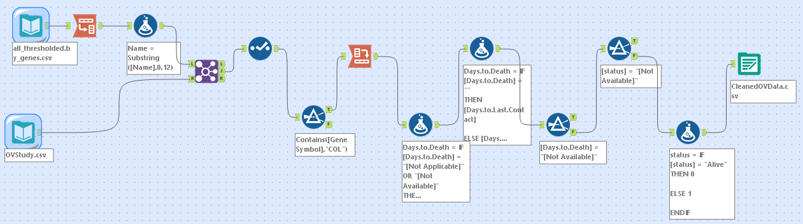  
  
Appendix B**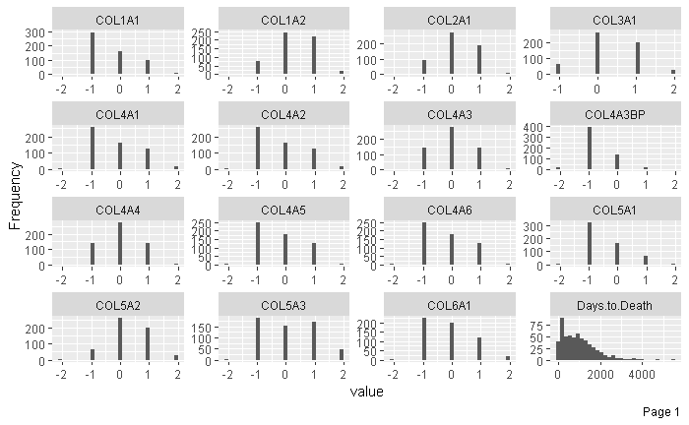

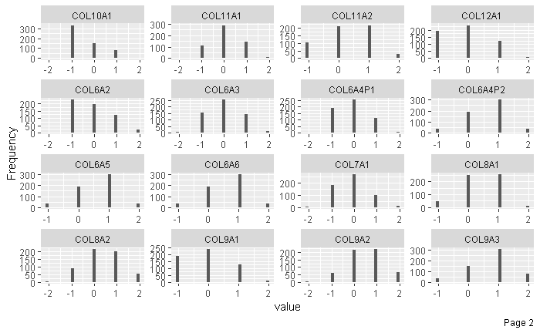

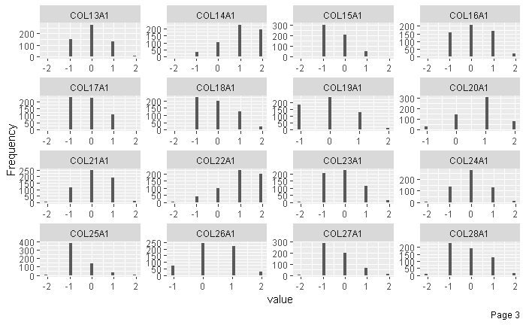

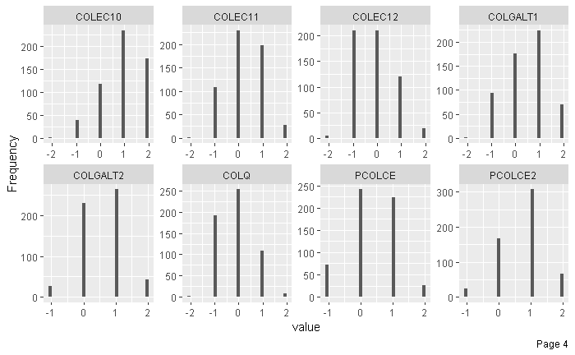

**Appendix C**

COL12A1

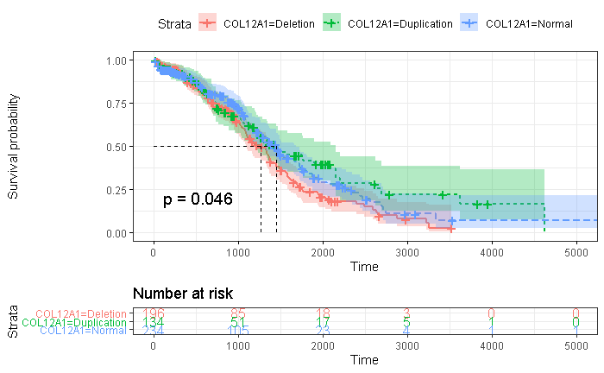

Figure COL12A1 survival has stratified curve of CNV changes (n = 564). Time is measured in days. Green illustrates duplicated copy number variation showing increased survival probability while red illustrates deletion of copy number variation displaying lower survival probability. Blue displays normal copy number variation. The model’s p-value of 0.046 demonstrates a statistically significant model when stratifying between COL12A1 duplication and deletion with regards to survival time. The dotted lines display the 50% survival probability between duplication, deletion, and normal copy number variation.

COL4A3BP

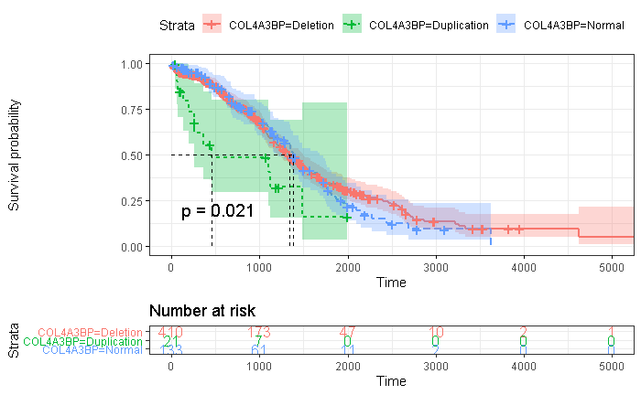

Figure COL4A3BP survival has stratified curve of CNV changes (n = 564). Time is measured in days. Green illustrates duplicated copy number variation displaying a decreased survival probability while red illustrates deletion of copy number variation. Blue displays normal copy number variation illustrating an increased survival probability compared to copy number variation duplication. The model’s p-value of 0.021 demonstrates a statistically significant model when stratifying between COL12A1 duplication vs normal and deletion copy number variation with regards to survival time. The dotted lines display the 50% survival probability between duplication, deletion, and normal copy number variation.

COL5A3

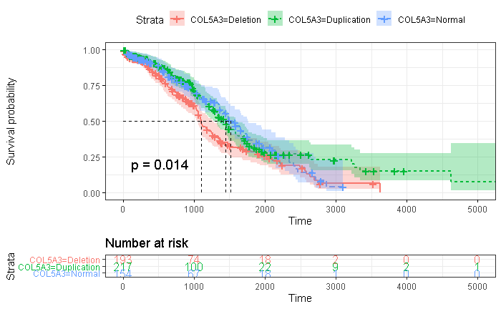

Figure COL5A3 survival has stratified curve of CNV changes (n = 564). Time is measured in days. Green illustrates duplicated copy number variation displaying an increased survival probability while red illustrates deletion of copy number variation illustrating a lower survival probability when compared to normal and duplicated copy number variation. Blue displays normal copy number variation. The model’s p-value of 0.014 demonstrates a statistically significant model when stratifying between COL5A3 deletion vs normal and duplicated copy number variation with regards to survival time. The dotted lines display the 50% survival probability between duplication, deletion, and normal copy number variation.

**Appendix D**

COL12A1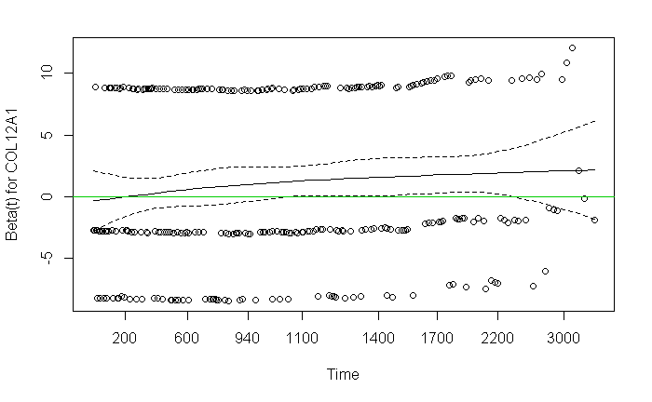

COL4A3BP

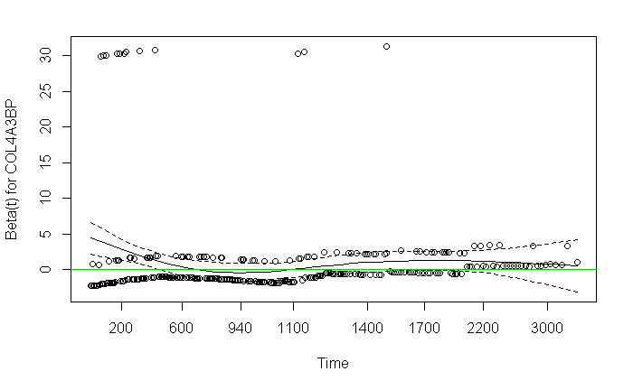

COL5A3

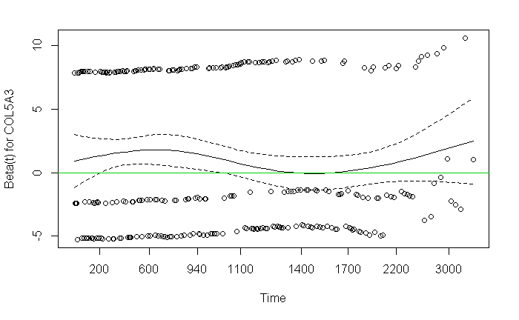

**Table of Abbreviations**

Ceramide Transfer (Protein) (CERT)

Copy Number Variation (CNV)

Collagen Gene 12A1 (COL12A1)

Collagen Gene 4A3BP (COL4A3BP)

Collagen Gene 5A3 (COL5A3)

Comma Separated Value (CSV)

Deoxyribonucleic Acid (DNA)

Exploratory Data Analysis (EDA)

Extra-cellular Matrix (ECM)

Genotype Tissue Expression Project (GTEx)

Kaplan-Meier (KM)

Medical Subject Heading (MeSH)

Not Applicable (NA)

Ovarian Cancer (OV)

Quantitative Polymerase Chain Reaction (qPCR).

Ribonucleic Acid (RNA)

The Cancer Genome Atlas (TCGA)

Transforming Growth Factor (TGF)